

Submitted by

I. Chandirasegaran

19384104

M.Sc. Computer Science

Integrated 5th Year

**Network and Web Technology Lab**

**HTML form Designing, Validation, and Database Storing**

**GitHub Link:** <https://github.com/Chandirasegaran/wt-and-network-lab-sem-9/tree/main/WT%20Ex%201>

**Page Live at:** <https://chandirasegaran.github.io/wt-and-network-lab-sem-9/WT%20Ex%201/index.html>

**Aim:**

To design an HTML form and validate using JavaScript and Connect to Database and store the data.

**HTML & PHP Code:**

<?php

// Database configuration

$servername = "localhost";

$username = "root";

$password = "2503";

$dbname = "studentreg";

// Create a connection to the database

$conn = new mysqli($servername, $username, $password, $dbname);

// Check the connection

if ($conn->connect_error) {

    die("Connection failed: " . $conn->connect_error);

}

// Initialize variables

$name = $regno = $fname = $mname = $dob = $email = $phone = $course = "";

$img_destination = "uploads/default.jpg";

$resume_destination = "uploads/default.pdf";

// Handle form data and file uploads

if ($_SERVER["REQUEST_METHOD"] == "POST") {

    $name = strtoupper($_POST["name"]); // Convert to uppercase

    $regno = strtoupper($_POST["regno"]); // Convert to uppercase

    $fname = strtoupper($_POST["fname"]); // Convert to uppercase

    $mname = strtoupper($_POST["mname"]); // Convert to uppercase

    $dob = $_POST["dob"];

    $email = $_POST["email"];

    $phone = $_POST["phone"];

    $course = $_POST["courselist"];

    // Handle image upload

    if (isset($_FILES["img-btn"]) && $_FILES["img-btn"]["error"] == 0) {

        $img_name = $_FILES["img-btn"]["name"];

        $img_tmp_name = $_FILES["img-btn"]["tmp_name"];

        $img_destination = "uploads/" . $regno . "_photo.jpg";

        // Move the uploaded image to a specified directory

        move_uploaded_file($img_tmp_name, $img_destination);

    }

    // Handle PDF resume upload

    if (isset($_FILES["res-btn"]) && $_FILES["res-btn"]["error"] == 0) {

        $resume_name = $_FILES["res-btn"]["name"];

        $resume_tmp_name = $_FILES["res-btn"]["tmp_name"];

        $resume_destination = "uploads/" . $regno . "_resume.pdf";

        // Move the uploaded PDF to a specified directory

        move_uploaded_file($resume_tmp_name, $resume_destination);

    }

    // Insert data into the database

    $sql = "INSERT INTO student_profiles (name, regno, fname, mname, dob, email, phone, course, image_path, resume_path)

            VALUES ('$name', '$regno', '$fname', '$mname', '$dob', '$email', '$phone', '$course', '$img_destination', '$resume_destination')";

    if ($conn->query($sql) === TRUE) {

        echo "Record inserted successfully";

    } else {

        echo "Error: " . $sql . "<br>" . $conn->error;

    }

}

// Close the database connection

$conn->close();

?>

<!DOCTYPE html>

<html lang="en">

<head>

    <meta charset="UTF-8">

    <meta name="viewport" content="width=device-width, initial-scale=1.0">

    <title>Student Profile</title>

    <link rel="icon" href="./assets/Images/favicon.png" type="image/jpg">

    <link rel="stylesheet" href="./assets/Styles/styles.css">

</head>

<body>

    <main>

        <div id="container">

            <!-- PU LOGO -->

            <span class="pulogo">

                <img src="./assets/Images/pulogo.png" alt="pu logo" id="pulogoid">

                <label for="pulogoid">Pondicherry University</label>

            </span>

            <!-- Title -->

            <span class="title">

                <h3 class="title">Create Your University Account</h3>

            </span>

            <form action="index.php" method="post" enctype="multipart/form-data">

                <div class="name">

                    <input type="text" name="name" required>

                    <label class="placeholderlable" for="name">Name</label>

                </div>

                <div class="regno">

                    <input type="text" name="regno" required>

                    <label class="placeholderlable" for="regno">Register Number</label>

                </div>

                <div class="fname">

                    <input type="text" name="fname" required>

                    <label  class="placeholderlable" for="fname">Father Name</label>

                </div>

                <div class="mname">

                    <input type="text" name="mname" required>

                    <label  class="placeholderlable" for="mname">Mother Name</label>

                </div>

                <div class="dob">

                    <input type="date" name="dob" placeholder="none" value="25-03-2002" required>

                    <label class="placeholderlableactive" for="dob">Date of Birth</label>

                </div>

                <div class="email">

                    <input type="email" name="email" id="emailinput" required>

                    <label class="placeholderlable" id="emaillabel" for="email">Email</label>

                </div>

                <div class="phoneclass">

                    <input type="tel" name="phone" id="phone" min='10' max='10' required>

                    <label class="placeholderlable" id="phonelabid" for="phone">Phone Number</label>

                </div>

                <div class="course">

                    <select name="courselist" class="courselist">

                        <option value="bsc">Bachelor of Computer Science</option>

                        <option value="msc">Master of Computer Science</option>

                        <option value="mca">Master of Computer Applications</option>

                        <option value="mtechcs">Master of Technology in Computer Science</option>

                        <option value="mtechnis">Master of Technology in Networks and Information Security</option>

                    </select>

                    <label class="placeholderlableactive" for="courselist">Select the Course</label>

                </div>

                <div class="photoupload">

                    <input type="file" name="img-btn" id="img-btn" accept="image/*" hidden />

                    <label class="puloadlable" for="img-btn">Upload Photo</label>

                    <span id="img-chosen">No file chosen</span>

                </div>

                <br>

                <div class="resumeupload">

                    <input type="file" name="res-btn" id="res-btn" accept="application/pdf" hidden />

                    <label class="ruloadlable" for="res-btn">Upload Resume</label>

                    <span id="res-chosen">No file chosen</span>

                </div>

                <br>

                <input type="submit" value="Create Account">

            </form>

        </div>

    </main>

    <script src="./assets/Scripts/app.js"></script>

</body>

</html>

**CSS Code:**

@font-face {

    font-family: PSans;

    src: url(../Fonts/Product\ Sans\ Regular.ttf);

}

* {

    font-family: 'PSans', 'Consolas';

    box-sizing: border-box;

}

body{

    background-image: url(../Images/background.jpg);

    background-repeat: no-repeat;

    background-position: center;

    background-size: cover;

    background-attachment: fixed;

}

main {

    display: flex;

    justify-content: center;

}

#container {

    background-color: white;

    width: auto;

    border-radius: 10px;

    height: auto;

    border-width: 2px;

    border-style: solid;

    padding: 3% 4%;

    /* padding-left: 5%; */

    /* display: flex; */

    /* flex-direction: column; */

    margin: 3%;

    align-items: center;

    border-color: rgb(190, 183, 183);

    box-shadow: 0px 10px 25px rgb(166, 165, 165);

border-radius: 1rem;

}

.puloadlable {

    background-color: #1b66c9;

    color: white;

    padding: 0.5rem;

    font-family: sans-serif;

    border-radius: 0.3rem;

    cursor: pointer;

    margin-top: 1rem;

}

.puloadlable:hover{

    background-color: hsl(214, 87%, 37%);

}

.ruloadlable:hover{

    background-color: hsl(214, 87%, 37%);

}

.ruloadlable {

    background-color: #1b66c9;

    color: white;

    padding: 0.5rem;

    font-family: sans-serif;

    border-radius: 0.3rem;

    cursor: pointer;

    margin-top: 1rem;

}

#img-chosen {

    margin-left: 0.3rem;

    font-family: sans-serif;

}

#res-chosen {

    margin-left: 0.3rem;

    font-family: sans-serif;

}

#pulogoid {

    width: 40px;

}

.pulogo>label {

    position: relative;

    top: -15px;

    left: 10px;

    font-weight: bolder;

    font-size: 1.3em;

}

.title {

    position: relative;

    top: -5px;

    font-size: 1.2em;

}

input[type=text],

input[type=email],

input[type=tel],

input[type=date] {

    width: 100%;

    padding: 12px 20px;

    transition: border-color 0.3s;

    outline: none;

    font-size: 16px;

}

input[type=text]:focus,

input[type=email]:focus,

input[type=tel]:focus,

input[type=date]:focus {

    border: 2px solid #1b66c9;

}

.courselist {

    width: 100%;

    padding: 12px 20px;

    transition: border-color 0.3s;

    outline: none;

    font-size: 16px;

}

.placeholderlable {

    position: relative;

    pointer-events: none;

    top: -34px;

    left: 20px;

    transition: top 0.3s, font-size 0.3s;

    font-size: 16px;

}

.placeholderlableactive {

    position: relative;

    top: -57px;

    left: 10px;

    font-size: 12px;

    background-color: white;

    padding-left: 5px;

    padding-right: 5px;

    color: #1b66c9;

}

input[type=text]:focus+.placeholderlable,

input[type=text]:valid+.placeholderlable {

    top: -57px;

    left: 10px;

    font-size: 12px;

    background-color: white;

    padding-left: 5px;

    padding-right: 5px;

    color: #1b66c9;

}

input[type=email]:focus+.placeholderlable,

input[type=email]:valid+.placeholderlable {

    top: -57px;

    left: 10px;

    font-size: 12px;

    background-color: white;

    padding-left: 5px;

    padding-right: 5px;

    color: #1b66c9;

}

input[type=tel]:focus+.placeholderlable,

input[type=tel]:valid+.placeholderlable {

    top: -57px;

    left: 10px;

    font-size: 12px;

    background-color: white;

    padding-left: 5px;

    padding-right: 5px;

    color: #1b66c9;

}

input[type=date]:focus+.placeholderlable,

input[type=date]:valid+.placeholderlable {

    top: -52px;

    left: 10px;

    font-size: 12px;

    background-color: white;

    padding-left: 5px;

    padding-right: 5px;

    color: #1b66c9;

}

.photoupload{

    margin-top: 10px;

    margin-bottom: 8px;

}

.resumeupload{

    margin-top: 8px;

}

input[type=submit]{

    background-color: #1b66c9;

    border: none;

    color: white;

    padding: 0.5rem;

    border-radius: 0.3rem;

    cursor: pointer;

    display: block;

    margin-left: auto;

    margin-bottom: auto;

}

@media (max-width:600px) {

    #pulogoid {

        width: 30px;

    }

    .pulogo>label {

        position: relative;

        top: -10px;

        left: 10px;

        font-weight: bolder;

        font-size: 1em;

    }

    .title{

        font-size: medium;

        margin-left: 2%;

    }

}

**JavaScript Code:**

document.querySelectorAll('input[type="text"]').forEach(function (input) {

  input.addEventListener('input', function () {

    this.value = this.value.toUpperCase();

  });

});

// Photo Upload Button

const iactualBtn = document.getElementById('img-btn');

const ifileChosen = document.getElementById('img-chosen');

iactualBtn.addEventListener('change', function () {

  ifileChosen.textContent = this.files[0].name

})

// Resume Upload Button

const ractualBtn = document.getElementById('res-btn');

const rfileChosen = document.getElementById('res-chosen');

ractualBtn.addEventListener('change', function () {

  rfileChosen.textContent = this.files[0].name

})

// Phone Number Validation

const phoneInput = document.getElementById('phone');

const plable = document.getElementById('phonelabid');

phoneInput.addEventListener('input', function (event) {

  const sanitizedValue = phoneInput.value.replace(/\D/g, '');

  phoneInput.value = sanitizedValue;

  if (sanitizedValue.length === 10) {

    phoneInput.style.borderColor = '';

    phoneInput.setCustomValidity('');

    plable.innerHTML = 'Phone Number';

    plable.style.color = '';

  } else {

    phoneInput.style.borderColor = 'red';

    phoneInput.setCustomValidity('');

    plable.innerHTML = 'Enter valid Phone Number';

    plable.style.color = 'red';

  }

});

// Email Validation

const emailInput = document.getElementById('emailinput');

const elabel = document.getElementById('emaillabel');

emailInput.addEventListener('input', function (event) {

  const emailValue = emailInput.value;

  const emailPattern = /^[a-zA-Z0-9._%+-]+@[a-zA-Z0-9.-]+\.(edu|com|net|org|in|co)$/;

  if (emailPattern.test(emailValue)) {

    emailInput.style.borderColor = '';

    emailInput.setCustomValidity('');

    elabel.innerHTML = 'Email';

    elabel.style.color = '';

  }

  else {

    emailInput.style.borderColor = 'red';

    emailInput.setCustomValidity('');

    elabel.innerHTML = 'Enter valid Email';

    elabel.style.color = 'red';

  }

});

// Preventing Submission from invalid email and Phone

const form = document.querySelector('form');

form.addEventListener('submit', function (event) {

  const emailValue = emailInput.value;

  const emailPattern = /^[a-zA-Z0-9._%+-]+@[a-zA-Z0-9.-]+\.(edu|com|net|org|in)$/;

  const sanitizedValue = phoneInput.value.replace(/\D/g, '');

  if (!emailPattern.test(emailValue)) {

    emailInput.style.borderColor = 'red';

    emailInput.setCustomValidity('');

    elabel.innerHTML = 'Enter valid Email';

    elabel.style.color = 'red';

    event.preventDefault(); // Prevent form submission

  }

  if (sanitizedValue.length !== 10) {

    phoneInput.style.borderColor = 'red';

    phoneInput.setCustomValidity('');

    plable.innerHTML = 'Enter valid Phone Number';

    plable.style.color = 'red';

    event.preventDefault(); // Prevent form submission

  }

});

**MySQL Query:**

CREATE DATABASE IF NOT EXISTS studentreg;

use studentreg;

CREATE TABLE IF NOT EXISTS student_profiles (

    id INT AUTO_INCREMENT PRIMARY KEY,

    name VARCHAR(255) NOT NULL,

    regno VARCHAR(20) NOT NULL,

    fname VARCHAR(255) NOT NULL,

    mname VARCHAR(255) NOT NULL,

    dob DATE NOT NULL,

    email VARCHAR(255) NOT NULL,

    phone VARCHAR(15) NOT NULL,

    course VARCHAR(255) NOT NULL,

    image_path VARCHAR(255) NOT NULL,

    resume_path VARCHAR(255) NOT NULL

);

SELECT *FROM STUDENT_PROFILES;

**Output Images:**

**Original Design**

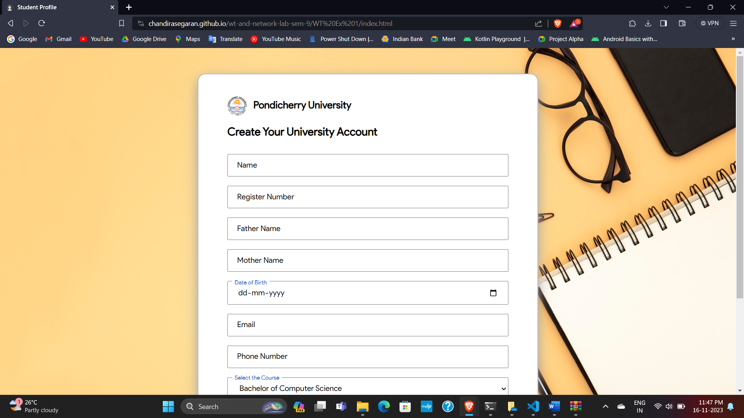

**Form validation showing error for E-mail and Phone Number field.**

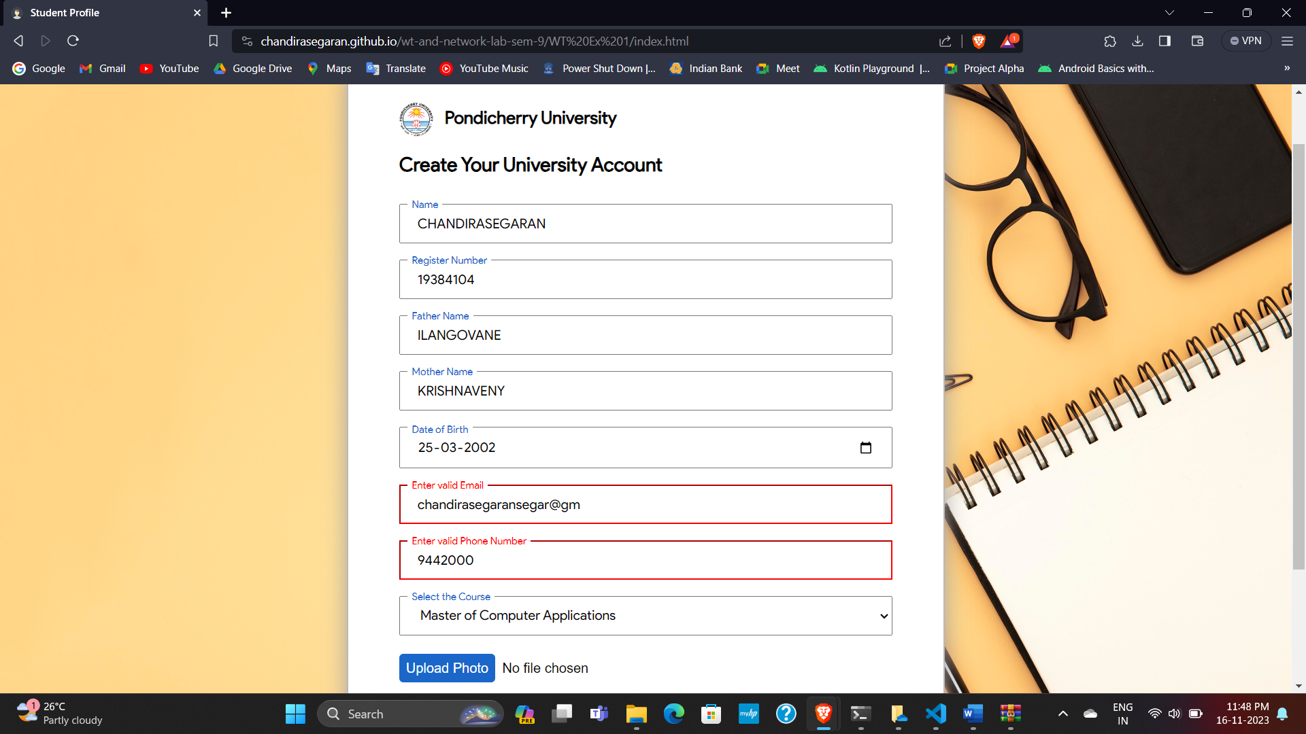

**Data stored in MySQL**

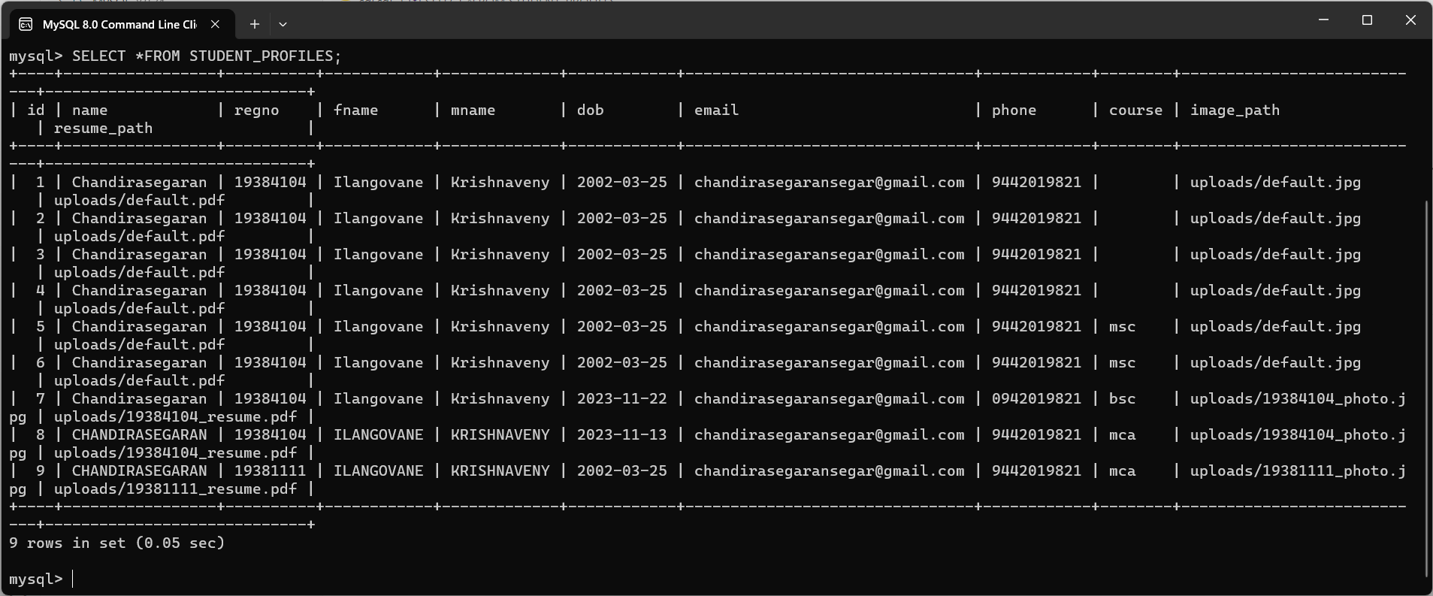

**Files stored in Uploads folder after successful submission**

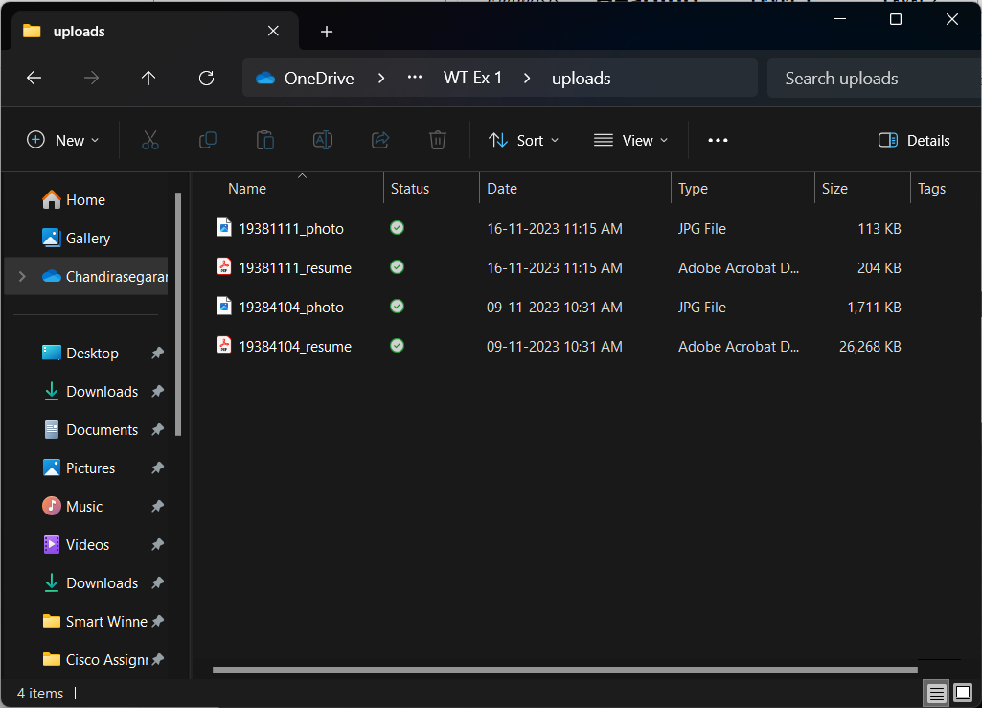

THANK YOU